**Enhancing Transport Efficiency through Predictive Maintenance:**

**A Machine Learning Approach Using NASA Turbofan Jet Engine Dataset**

Nishant Doshi1,Ansh Soni2 , Krish Modi3, Aneri Shah4

1Computer Engineering Department , Pandit Deendayal Energy University (e-mail:[nishant.doshi@sot.pdpu.ac.in](mailto:nishant.doshi@sot.pdpu.ac.in))

2Computer Engineering Department , Pandit Deendayal Energy University (e-mail: [ansh.soni0403@gmail.com](mailto:ansh.soni0403@gmail.com))

3Computer Engineering Department , Pandit Deendayal Energy University (e-mail: [krishmodi33@gmail.com](mailto:krishmodi33@gmail.com))

4Computer Engineering Department , Pandit Deendayal Energy University (e-mail: [anerishah2424@gmail.com](mailto:anerishah2424@gmail.com))

**1. Abstract**

A successful and efficient transportation system depends on the credibility of engines and machinery [I]. With the help of [NASA Turbofan Jet Engine dataset](https://www.kaggle.com/datasets/behrad3d/nasa-cmaps), this paper focuses on the predictive maintenance[II] framework to boost transport efficiency by leveraging sensor data. With the help of machine learning algorithms, we predict the Remaining Useful Life (RUL) of engine components based on training the model with appropriate algorithms that prompt scheduled services and maintenance to reduce downtime. Feature engineering techniques and predictions of RUL, Health Index(HI), and degradation score- the proposed model provides a methodology for enhancing system dependability and minimizing maintenance costs. This study provides valuable insights into current transportation setbacks.

**Keywords** : Feature Engineering, NASA Turbofan Jet Engine, Predictive Maintenance, Remaining Useful Life.

**2. Introduction**

The transport industry is an inevitable portion of transnational trade where functional productivity and consistency are essential. With the present sophisticated engines, primitive maintenance strategies are unable to cope to prevent damage resulting in expensive breakdowns and workflow disturbances. The model is prepared based on study by incorporating the predictive maintenance framework that leverages advancements in sensor technology and machine learning algorithms. The traditional methods follow routine services of engines which are inefficient in overlooking critical wear and tear and may cause unscheduled downtimes. This also leads to escalating maintenance costs and endangers safety. Predictive maintenance provides a powerful way to use real-time inspection data to identify potential problems before they become major failures.

Exploiting the NASA Turbofan Jet Engine dataset, which makes use of sensor data from various operational units, the research aims to predict Remaining Useful Life (RUL)of engine components. The dataset’s diverse range of operational conditions provides an excellent basis for developing robust predictive models. By effectively forecasting RUL, transportation operators can optimize their maintenance schedules, thereby minimizing downtime and reducing overall maintenance costs.

**2.1 Objectives:**

1.)To develop a predictive model that estimates RUL using machine learning technique.

2.)To enhance the model's accuracy through feature engineering and data preprocessing.

3.)To showcase the proposed approach's scalability and real-world applicability in transportation.

**3. System Models**

The surveillance of engine performance is necessary for reliable modern transportation systems. Sensors are strategically positioned throughout the engine to continuously gather data on critical parameters such as temperature, pressure, vibration, airflow, fuel flow, exhaust gas composition, speed, and overall efficiency . [III] Each type of sensor serves a specific function and is placed in locations such that it captures accurate readings. For example, temperature sensors are installed in the combustion chamber and turbine inlet to monitor overheating, while pressure sensors are located in compressor stages and exhaust flows to detect leaks or mechanical failures. Vibration sensors are mounted on rotors and bearings to identify potential imbalances or wear.

Modern engines are incorporated with high-tech sensors that consistently collect real-time data on parameters like temperature, pressure, vibration, speed, airflow. Based on the dataset, machine learning algorithms enable the proactive predictive maintenance by applying statistical evaluation that predicts malfunctions and thereby enhances engine efficiency. [IV]

**3.1 Remaining Useful Life (RUL) Prediction**

RUL estimates the cycles remaining before machine/component failure. With this, we can prevent unpredicted shutdowns by scheduling maintenance tasks.

RULi = Tmax - Ti  (1)

RULi ​: Remaining useful life of unit iii in cycles or time. [V]

Tmax ​: Total cycles/time until failure (from training data or simulation).

Ti ​: Current cycle/time of the engine or component.

**3.2 Health Index (HI) Calculation**

The Health Index is a normalized metric indicating engine degradation.

Health Index is the method of calculating how much the engine have degraded according to its use over time

$HI= 1-\frac{Sensor Deviation}{Max Deviation}$ (2)

If the health Index is 1 it means the engine is fully healthy and if 0 then failure, it varies from 0 to 1. It is very useful to monitor the long term trends via visualization.

The Health Index provides engine degradation, ranging from 1 (fully healthy) to 0 (failure). It is particularly useful for visualizing long-term trends.

**3.3 Degradation Score**

$Degradation Score_{i} = \frac{ \sum_{j=1}^{n}{} w_{j} ⋅Sensor_{j}}{n}$ (3)

The degradation score quantifies cumulative wear based on time-series sensor data. It serves as a unit for tracking engine reliability over time.

**3.4 Sensor Threshold-Based Failure Detection**

Set thresholds for key sensors to flag failures.

$Failure Flag = \{1 if Sensor_{i }> Threshold_{i}$

0 otherwise (4)

**3.5** **Time-to-Failure Distribution (Weibull Analysis)**

A statistical approach to model time-to-failure.

$f(t) = \frac{β}{η} (\frac{t}{η})^{β-1} e ^{-(\frac{1}{η})^{β}}$

* t: Time
* $η$: Scale parameter (characteristic life)
* $β:$ Shape parameter (failure rate trend)

**Cumulative Distribution Function (CDF):**

F(t) = 1- $e^{-(\frac{1}{η})^{β}}$ (5) 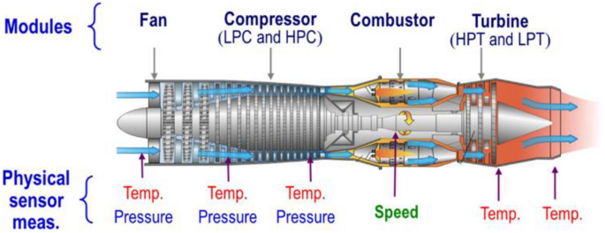

This formula provides a relation for assessing engine health and predicting Remaining Useful Life (RUL). Metrics like the Health Index (HI) and degradation scores quantify engine condition, enabling proactive maintenance to reduce downtime and improve efficiency. Evaluation metrics such as Mean Squared Error (MSE) enhance model accuracy, while time-to-failure models like the Weibull distribution reveal failure trends for risk assessment and lifecycle management. Normalization and threshold Fig I- A novel transformer-based DL model[VI]

F(t) = 1- $e^{-(\frac{1}{η})^{β}}$ (6)

methods standardize sensor data analysis, ensuring consistent decision-making. Together, these tools form a diversified engine health management system.

Table - I : Table on different types of Sensors,function which need to be mounted on engines [VIII,IX]

| **Sensor Type** | **Location** | **Fitting Method** | **Purpose** | **Typical Sensors** |
| --- | --- | --- | --- | --- |
| Temperature Sensors | Combustion chamber, turbine inlet, cooling systems | Mounted using brackets, welded, or inserted into ports | Monitor temperature to detect overheating and cooling efficiency | K-type thermocouple, RTD sensors (PT100/PT1000) |
| Pressure Sensors | Low-pressure/high-pressure compressor stages, combustion chamber, exhaust flow | Mounted in pipes or ducts | Measure pressure changes indicating leaks, clogging, or failures | Honeywell 26PC Series, Endress+Hauser Cerabar |
| Vibration Sensors | Rotors, bearings, shafts | Mounted directly onto components using screws or brackets | Detect unusual vibrations due to misalignment or wear | PCB Piezotronics 356A16, Monitran MTN/2 |
| Fuel Flow Sensors | Fuel delivery lines | Installed in fuel lines | Measure fuel flow rate for optimal combustion | Emerson Micro Motion, Brooks Instrument 5850 |
| Airflow Sensors | Air intake ducts | Placed at intake points | Measure air flow rate for proper engine performance | Honeywell AWM Series, Aalborg AFS-213 |
| Exhaust Gas Sensors | Exhaust manifold, tailpipe | Installed in exhaust pipes or manifold | Monitor emissions and gas temperatures | Bosch LSU 4.9 Lambda Sensor, Figaro TGS Series |
| Speed Sensors | Low-pressure/high-pressure compressors, turbine | Mounted near rotating components | Measure rotational speed to identify imbalances or wear | Honeywell 3450, Bourns SRN Series |
| Efficiency and Flow Rate Sensors | Engine output, fuel system, airflow system | Installed along exhaust or airflow ducts | Monitor overall engine performance and efficiency | Yokogawa ROTAMASS, Emerson Rosemount 3051 |

**4. Experimental Analysis**

This paper presents a method for predicting the Remaining Useful Life (RUL) of turbofan engines with the help of advanced sensor data analytics with machine learning[X]. The approach we have used addresses the complexities of engine health monitoring and predictive maintenance. We have supported the research by an experimental framework and graphical evaluations of the outcomes.

The dataset used in this research is obtained from *NASA's CMAPSS* repository. This includes a wide range of sensor readings and operational conditions. Data preprocessing is done here to obtain the pattern in the dataset, henceforth improving the accuracy of predictions. More accurate the predictions, better the work on proactive maintenance period in turbofan engine operations.

**4.1 Methodology**

First, we concentrated on data gathering and preprocessing. We have used sensor data from NASA's CMAPSS dataset. Cleaning the raw dataset by eliminating noise, outliers, and incomplete records was the next goal. Then we researched a technique that is a multi-layered strategy to handle the challenges of engine health monitoring and predictive maintenance.[XI]

We next standardized the sensor data to remove scale variations and engineering features like the Health Index (HI) and Degradation Score [XII]. The most influential sensors were found and kept using dimensionality reduction techniques, such as correlation analysis, which simplified further calculations. Now we were able to identify the trends.

Correlation heatmaps give the sensor interdependencies. This helped in feature selection. Then we coined the Remaining Useful Life(RUL) by using a machine learning model on degradation data. Also, the Health Index [XIII] for the degradation of the engine over a cycle is calculated and Weibull Analysis quantifies probability of failure so that maintenance can be scheduled as necessary.Additionally, we explored time-series trends of individual sensors to link deviations to specific failure mechanisms.

We thoroughly tested the strength and accuracy of our model using statistical measures like Mean Absolute Error (MAE) and R-squared on a variety of test cases. To make the results more understandable and practical, we used visual tools such as heatmaps, time-series graphs, and reliability curves. These visuals bridged the gap between theoretical modeling and real-world applications, demonstrating the model’s capability in predicting maintenance[XIV] needs for turbofan engines.

**4.2 Graphical Analysis**

**Principal Component Analysis (PCA) Scatter Plot**

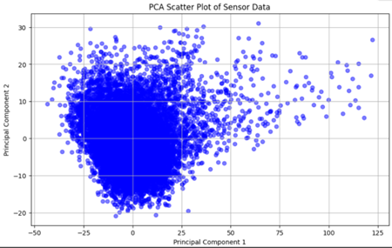

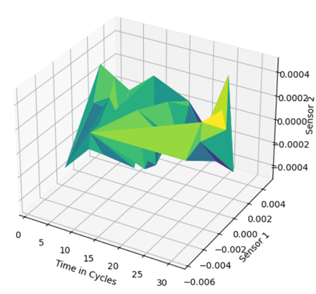

Fig-II : Principal Component Analysis (PCA) Scatter Plot. Fig III : 3D Surface Plot for Multi-Dimensional Sensor Data

The scatter plot highlighting Principal Component Analysis (PCA) based on the sensor's data is plotted where the x-axis represents Principal Component 1 (PC1), where higher diversity in the data is observed, the y-axis demonstrates Principal Component 2 (PC2) that shows the second most significant variance in data. Each and every point in the scatter plot marks a relation with a single observation in engine data and points forming clusters indicate sensor data. Outliers present in the graph indicate the abnormal trends in the dataset that need to be verified again or more technical investigation.This PCA visualization aids in understanding engine health and behavior, providing valuable insights for predictive maintenance models by highlighting clusters, outliers, and trends.

**3D Surface Plot for Multi-Dimensional Sensor Data**

The 3D face plot visualizes the relationship between three variables (Fig. III)’

Time in Cycles(x-axis) Represents the functional life of the machine.

Detector 1( y-axis) Represents the readings from the first detector.

Detector 2( z-axis) Represents the readings from the alternate detector.

The face itself shows how detector values change over time. Peaks and dents indicate advanced and lower values, independently. The colormap(' viridis' in this case) provides another dimension of information, frequently representing the magnitude of the z- values(Detector 2).

**Heat Map based on correlation with Sensor Data**

A heatmap visualizes sensor interrelations to identify redundancy and key contributors to engine degradation.[XV]

The heatmap highlights essential interdependencies between sensors, facilitating several key strategies for enhancing predictive maintenance. By identifying redundant sensors with high correlations, we can simplify the model through feature selection and dimensionality reduction techniques, such as Principal Component Analysis (PCA) or feature combination. Additionally, clustering correlated sensors allows for targeted analysis of specific engine subsystems and failure patterns. Incorporating these relationships into predictive models [XVI] can significantly improve prediction accuracy. Overall, this approach enhances our understanding of the dataset, optimizes model performance, and streamlines maintenance strategies, leading to more effective and proactive engine management

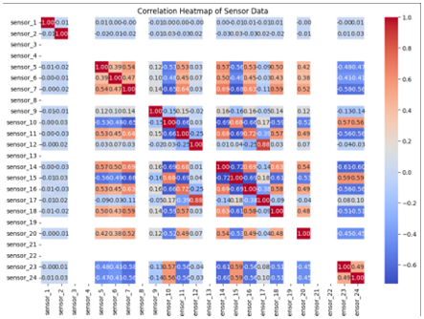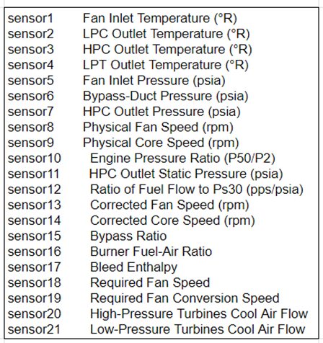

Fig-IV: Heat Map based on correlation with Sensor Data. Table-II: Types of Sensors - convention used in charts

**4.3 Model Accuracy Analysis**

Remaining Useful Life (RUL) estimates the cycles before a machine fails. It analyzes sensor data and degradation patterns. It is crucial in predictive maintenance. RUL acts as a proactive tool for timely maintenance, reducing downtime, optimizing schedules, cutting costs, and enhancing safety, especially in high-risk sectors like aviation and industry. Although, the accuracy is dependent on the quality of sensor data, condition of environment and choice of model degradation and Machine learning algorithm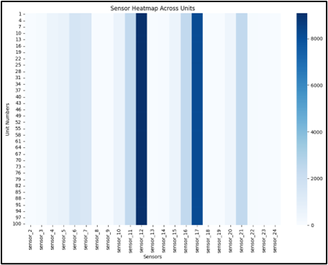

The heatmap based on a pandas DataFrame with sensor readings over

time, shows the average sensor values for every unit in the dataset. The rows represent units and columns represent sensors after aggregating data by 'unit_number.' The color intensity indicates average sensor values, darker the blue hues higher the values. Sensor variation across units, possible anomalies indicated by abnormally high or low values, and preliminary insights into sensor relationships are revealed by analyzing the heatmap. This visualization can help with root cause analysis by highlighting anomalous sensor values, guide operational optimization by exposing conditions that improve performance, and inform predictive maintenance by identifying early warning signs associated with engine failures.

**Fig V- Sensor Failure Heatmap Across Units**

**Potential Biases and Limitations of the NASA Dataset :**

The NASA Turbofan Jet Engine dataset has misjudgments and weaknesses that affect the model results:

a)Constrained use cases: The data is stimulated only for specific conditions, and a major gap for real-world practical engine performance.As a result model inaccuracy and scalability are unseen in certain scenarios.

b)Artificially generated data: The data captured and trained is not 100 percent real-world sensor-based but has major divergences with actual engine data.

c)Sensor inconsistency: While collecting sensor data failures are observed that ultimately make the AI/ML model less reliable.

d)Data Homogeneity: The data is not gathered from a variety of engines that can make our model scalable and varied in all applications but the data is of specific engine configuration that makes the result vary with proactive predictions.

**Integration of the Framework into Existing Industrial Systems:**

Table III - Challenges and Solutions to integrate with existing Industrial Systems.

|  | **Challenge** | **Solution** |
| --- | --- | --- |
| **Infrastructure Compatibility** | Existing systems have legacy equipment with limited connectivity and incompatible data formats. | IoT gateways can be deployed in order to fill the difference between sensors and traditional equipment in order to establish real-time communication with the central system. |
| **Data Acquisition & Management** | Industrial environments often produce amounts of heterogeneous data, posing challenges in storage, processing, analysis. | Industry 4.0 technologies like cloud computing platforms, big-data tools and frameworks like Spark or Hadoop have high strength in data storage. Data lakes can also be used in order to monitor diverse datasets for cohesive analysis. |
| **Real-Time Monitoring & Processing** | Requires high computational resources and low-latency communication. | Integrate edge computing for on-site data filtering and preprocessing, while leveraging cloud computing for intensive tasks, creating a hybrid model for efficient real-time operations |
| **System Scalability** | Industrial systems often operate under strict regulatory frameworks that require adherence to safety and operational standards. | Adaptive distributed system architecture along with cloud computing technologies to scale up data from different platforms. Microservices can be also used in order to cope if new units are established. |
| **Regulatory Compliance** | Advanced optimization techniques, such as incremental learning, can update models dynamically with incoming data, maintaining accuracy over time. | Align the framework with industry standards like ISO 55000 or aviation safety norms, and collaborate with regulatory bodies to ensure compliance. |

**4.4 Key Observations**

**Sensor Integration:** The proposed model uses a comprehensive set of multi- sensor data for predictive maintenance to monitor critical engine parameters, such as vibration, pressure, and temperature ensuring precise tracking of degradation trends.

**Accurate RUL Estimation:** By combining statistical approaches with sensor data analysis, the model provides highly reliable predictions of Remaining Useful Life (RUL) allowing maintenance teams to plan interventions, avoiding unexpected failures and reducing downtime.

**Health Index as a Diagnostic Metric:** The Health Index (HI) acts as a unified measure of engine health, offering a monotonic and interpretable decline that clearly signals degradation, simplifying the decision-making process for operators.

**Enhanced Failure Prediction:** The hybrid methodology, integrating sensor thresholds with statistical models like Weibull analysis captures both immediate anomalies and long-term degradation trends, providing a broad range of failure-detection framework.

**Improvements in operational efficiency:** Predictive maintenance strategies reduce the possibility of engine failure and increase overall efficiency.This way it contributes to cost savings and improvised reliability in industrial applications.

**Scalability and Flexibility:** The adaptive and analytics-driven design ensures the model is easily adapted across all domains like aviation, power generation, and manufacturing.

**Data-powered advancements:** The model successfully sets a benchmark to set the transition from a traditional maintenance approach to proactive predictive maintenance. This successfully plays a major role in increasing consistency and operational excellence. This transitional model successfully contributes to increasing transport efficiency and ensures a longer lifespan of important engine parts.

**5. Result and Discussion**

The key components of the predictive maintenance model i.e. sensor integration and AI/ML predictive models are highlighted in the study that focuses on increasing transport efficiency. The model has been trained with the given dataset that comprises RUL prediction, Health Index(HI) computation, Degradation Score analysis, and Weibull analysis.

**5.1 Enhanced Productivity With RUL Forecasting**

The model reduces the failure chances of engines by the methodology of predictive maintenance actions that estimate RUL of engine components.

**5.2 Monitoring Effectively Using the Health Index**

Health Index (HI) is an important parameter that helps to understand the degradation pattern beforehand.

Outcome: HI below 0.4 is classified as high threat potential.

**5.3 Calculated Degradation Rating for Upkeep Scheduling**

The degradation score measures the amount of component damage to parts and allows successful predictions to schedule maintenance.

**5.4 Threshold-Based Failure Detection**

By defining the sensor threshold value beforehand and with predictive maintenance technology of early failure detection we can reduce the component damage.

**5.5 Using Weibull Analysis to Predict Time to Failure**

Weibull distribution curve offers a statistical analysis to understand the pattern of component failures. This analysis prioritizes high-risk components and it highlights the soundness and degradation chances over the operational cycles.

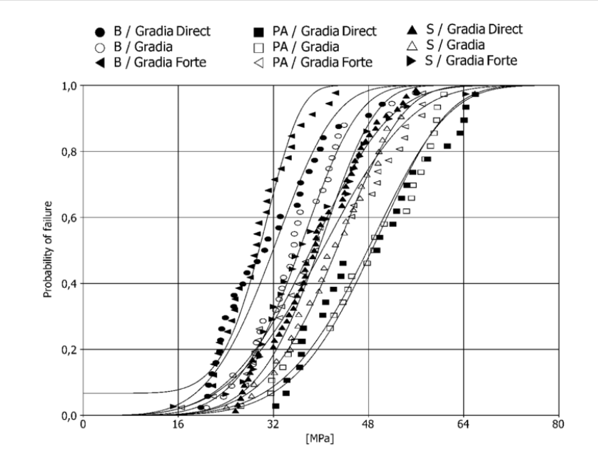

The graph shows the pattern that over 300 cycles, reliability reduced to 50% during its first 100 cycles which was 90% initially.

Fig VI : Weibull distribution curve: probability of failure as a function of stress. B: bur roughening; S: sandblasting;[VII]

**Discussion**

**5.6 Operational Benefits**

Improved effectiveness: The predictive maintenance techniques increase engine efficiency by predicting faults and reducing the threats of wear and tear of engine parts.

Minimizing cost: early prediction of faults and prompting early maintenance reduces repair costs and major damage to engines and wear and tear.

Prolonged component durability: predetection of faults plays a major role in prompting urgent services needed and ensure smooth handling and usage of engine parts which ultimately increases the operational lifespan.This ultimately plays a major role in improving resource management.

This way the model detects the issues and thus prompts the urgency of services needed which contributes to cost reduction, increases durability of parts, and thus enhances transport efficiency.

**6. Future Scopes**

Predictive maintenance models in the future have high capability to evolve at a larger scale in the future.Potential areas where this research can be carried forward are:

1. Integration with AI and Machine Learning: Can be developed with more sophisticated technologies like deep learning or LLM can be incorporated. Automated intelligent learning models can adjust thresholds and enhance performance over time

2. IoT and Edge Computing: Using Internet of Things (IoT)[XVIII] sensors to gather and process real-time data to minimize delays and increase agility .IoT-enabled technology can help streamline the monitoring of complex human-machine interactions.

3. Enhanced Visualization Tools: Creating advanced dashboards with augmented reality (AR) or virtual reality (VR) interfaces can enable rapid diagnostics. Interactive graphics and predictive simulations will help workers make informed decisions.[XIX]

4. Cybersecurity for Sensor Data: Ensuring the security and integrity of sensor data is important to prevent cyberattacks. Utilizing blockchain technology can enhance the security of data storage and sharing.

5. Scalability for Fleet-Wide Monitoring: The focus is on scaling the system to monitor an entire fleet of machines or vehicles in large operations. Creating a centralized cloud-based monitoring solution for multiple locations will improve overall monitoring performance.

6. Standard frameworks and policy formulation: Standard regulations can be established for sensor placement into engines. Industrial policies can be developed to set uniform guidelines and policy strategies.

With these future scopes predictive maintenance systems can form a strong pillar of Industry 4.0, and have the potential to foster smarter and efficient activities in broad-ranging domains.

**6.1 Scalability of the Framework for Real-Time IoT Applications**

Table IV : Potential and Challenges faced to scale the model with Real-Time IOT Applications

|  | **Potential** | **Challenge** |
| --- | --- | --- |
| **Real-Time Data Integration:** | The framework's reliance on sensor data aligns well with IoT ecosystems, enabling continuous monitoring and rapid data acquisition. | Real-time processing demands robust computational resources to handle large-scale, high-frequency data streams without latency. |
| **Edge Computing:** | Implementing edge computing techniques can localize data processing near IoT devices, reducing transmission delays and enhancing real-time decision-making. | Edge devices must be capable of running machine learning models, lightweight algorithms optimized for lower computational power. |
| **Scalable Cloud Infrastructure:** | Cloud-based platforms provide the necessary scalability to analyze data from multiple engines or systems simultaneously, supporting fleet-wide monitoring. | Ensuring secure and efficient data transfer to the cloud, particularly in bandwidth-constrained environments, remains a concern. |
| **System Adaptability** | The modular design of the framework allows adaptation to diverse IoT systems and sensor configurations. | Customizing the framework for specific industry requirements can increase initial deployment time and costs. |
| **Predictive Model Optimization** | Advanced optimization, like incremental learning, dynamically updates models to maintain accuracy. | Balancing model complexity with real-time processing capabilities is a critical trade-off. |

**7. Conclusion**

The prediction of Remaining Useful Life (RUL) and the study of predictive maintenance play a major role in enhancing transport efficiency. The method successfully predicts the part deterioration by statistical analysis models and real-time sensor data.

***The incorporation of several important parameters like RUL, Degradation Score, and Health Index(HI) is integrated into this model. This model plays a major role in cost reduction, and resource efficiency and overall contributes to improving transport efficiency. Various insights and visualization charts like Weibull distribution curve, Sensor failure heatmap, and 3D Surface plot for Multi-Dimensional Sensor Data promote a deeper understanding of the relationship between sensor data and engine performance.***

***By analyzing the RUL pattern [XX] it monitors probable issues and identifies all the urgent care and services that need to be addressed.***

**8. Acknowledgements**

The work in this paper is carried out in the machine provided by GUJCOST under project “Developing a Privacy Preserving Framework for securing Organizational Data Publication” .

**9. References**

[I] Jelti, F.; Allouhi, A.; Tabet Aoul, K.A. Transition Paths towards a Sustainable Transportation System: A Literature Review. Sustainability 2023, 15, 15457.<https://doi.org/10.3390/su152115457>

[II] A. Saxena, K. Goebel, D. Simon and N. Eklund, "Damage propagation modeling for aircraft engine run-to-failure simulation," 2008 International Conference on Prognostics and Health Management, Denver, CO, USA, 2008, pp. 1-9, doi: 10.1109/PHM.2008.4711414.

[III] Lee ET, Eun HC. Optimal Sensor Placement in Reduced-Order Models Using Modal Constraint Conditions. Sensors (Basel). 2022 Jan 13;22(2):589. doi: 10.3390/s22020589. PMID: 35062551; PMCID: PMC8779765.

[IV] Sahil Bhagat, Sanjeev Gupta, Pardeep Singh - Estimation and Analysis of Remaining Useful Life (RUL) of Critical Mechanical Components in Tractor, International Journal for Multidisciplinary Research (IJFMR).

[V] Chen, X. A novel transformer-based DL model enhanced by position-sensitive attention and gated hierarchical LSTM for aero-engine RUL prediction. Sci Rep 14, 10061 (2024).<https://doi.org/10.1038/s41598-024-59095-3>

[VI] Chen, X. A novel transformer-based DL model enhanced by position-sensitive attention and gated hierarchical LSTM for aero-engine RUL prediction. Sci Rep 14, 10061 (2024).<https://doi.org/10.1038/s41598-024-59095-3>

[VII] Dall'Oca, Susanna & Papacchini, Federica & Radovic, Ivana & Polimeni, Antonella & Ferrari, Marco. (2008). Repair potential of a laboratory-processed nano-hybrid resin composite. Journal of oral science. 50. 403-12. 10.2334/josnusd.50.403.

[VIII] Yilong Wang, Zhengbao Yang, Pengyu Li, Dengqing Cao, Wenhu Huang, Daniel J. Inman, Energy harvesting for jet engine monitoring, Nano Energy, Volume 75, 2020, 104853, ISSN 2211-2855,<https://doi.org/10.1016/j.nanoen> 2020.104853.

[IX] Borguet, Sebastien & Leonard, Olivier. (2008). A Study on Sensor Selection for Efficient Jet Engine Health Monitoring.

[X] Zeqi Zhao, Bin Liang, Xueqian Wang, Weining Lu, Remaining useful life prediction of aircraft engine based on degradation pattern learning, Reliability Engineering & System Safety, Volume 164, 2017, Pages 74-83, ISSN 0951-8320,<https://doi.org/10.1016/j.ress.2017.02.007>.

[XI] Khan, Khalid, et al. "Recent trends and challenges in predictive maintenance of aircraft’s engine and hydraulic system." Journal of the Brazilian Society of Mechanical Sciences and Engineering 43 (2021): 1-17.

[XII] Nemani, Venkat, et al. "Health index construction with feature fusion optimization for predictive maintenance of physical systems." Structural and Multidisciplinary Optimization 65.12 (2022): 349.

[XIII] Yang, Hanbo,et al. "Remaining useful life prediction for machinery by establishing scaled-corrected health indicators." Measurement 163 (2020): 108035.

[XIV] Dong, Dong, Xiao-Yang Li, and Fu-Qiang Sun. "Life prediction of jet engines based on LSTM-recurrent neural networks." 2017 Prognostics and System Health Management Conference (PHM-Harbin). IEEE, 2017.

[XV] Zhao, Zeqi, et al. "Remaining useful life prediction of aircraft engine based on degradation pattern learning." Reliability Engineering & System Safety 164 (2017): 74-83.

[XVI] C. Zheng et al., "A Data-driven Approach for Remaining Useful Life Prediction of Aircraft Engines," 2018 21st International Conference on Intelligent Transportation Systems (ITSC), Maui, HI, USA, 2018, pp. 184-189, doi: 10.1109/ITSC.2018.8569915.

[XVII] Taha, Hussein A., Ahmed H. Sakr, and Soumaya Yacout. "Aircraft engine remaining useful life prediction framework for industry 4.0." Proceedings of the 4th North America conference on Industrial Engineering and Operations Management, Toronto, ON, Canada. 2019.

[XVIII] Kumar, Vinod, M. Prakash, and Sam Thamburaj. "Deep Learning-based Predictive Maintenance for Industrial IoT Applications." 2024 International Conference on Inventive Computation Technologies (ICICT). IEEE, 2024.

[XIX] Tan, Jonathan S., and Mark A. Kramer. "A general framework for preventive maintenance optimization in chemical process operations." Computers & Chemical Engineering 21.12 (1997): 1451-1469.

[XX] Kang, Ziqiu et al. “Remaining Useful Life (RUL) Prediction of Equipment in Production Lines Using Artificial Neural Networks.” Sensors (Basel, Switzerland) vol. 21,3 932. 30 Jan. 2021, doi:10.3390/s21030932.